INITIAL APPLICATION FOR
MATTHEW W. FREEMAN MEMORIAL SCHOLARSHIP
2025

VIETNAM VETERANS OF AMERICA
CHAPTER 920
DENTON, TEXAS

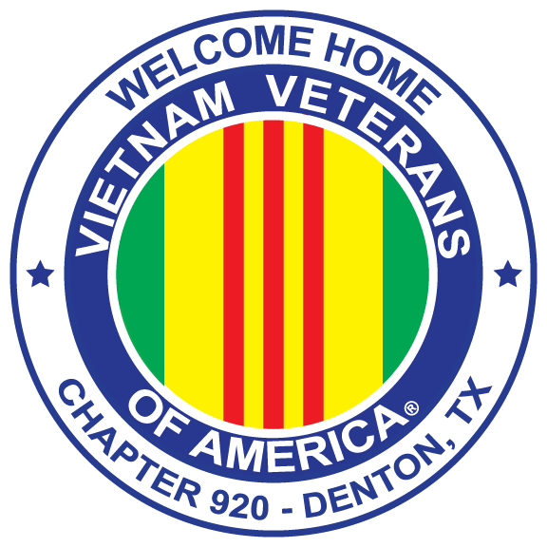

APPLICANT NAME: ________________________________________________

INITIAL APPLICATION FOR MATTHEW W. FREEMAN MEMORIAL SCHOLARSHIP
VVA 920 DENTON, TEXAS
The Matthew W. Freeman Memorial Scholarship was established to honor the memory of Matthew Freeman who died in an automobile accident while attending the United States Military Academy. More than one scholarship will be awarded by VVA 920.
Eligibility: The applicant must be a dependent or relative of a member of VVA Chapter 920, Denton, Texas. (Spouses, children, including foster or stepchildren, grandchildren, or great-grandchildren).
Application: Application A is to be completed when the applicant has not received a prior scholarship from VVA Chapterl920.
PERSONAL INFORMATION
Name: _________________________________ Date of Birth: _______________________________
Street Address: __________________________ City: _________ St: _________ Zip Code: _________
Phone Number (Cell): _______________________ Home: ___________________________________
Current email address: _______________________________________________________________
Name of sponsoring VVA 920 Member: _________________________________________________
Relationship to VVA 920 Member _____________________________________________________
High School: ____________________________ Address: ___________________________________
Year Expected to Graduate: ____________________________ GPA: _________________________

BIOGRAPHICAL INFORMATION
Tell the scholarship committee about yourself, awards received, recognition, and participation in the following categories.
- Church and Community
- Hobbies
- Part-time work/jobs
- Your favorite leisure time activities
- Volunteer activities

Post-Secondary School Plans and Information
- University/College/Vocational School where you have been accepted and plan to attend. Provide address of the school.
- Proposed major, degree sought and or certifications.
- Planned date and semester of enrollment.
- If the applicant has completed dual-credit courses from a community college, transcripts of courses completed or enrolled in are required.
Letters of Recommendation
Two letters of recommendation are required. The letters of recommendation are to be completed by individuals who have knowledge of the applicant and can speak to your probability of success in the selected field of study. Letters are to address the applicant’s:
- Academic performance in high school
- Character
- Communication skills
- Interests
- Involvement in school and community
- Leadership
Letters of recommendation must be sent to the Chair of the Scholarship Committee. No messaging is accepted. Lloyd Kinnison, Scholarship Chair, VVA Chapter 920, PO Box 241, Denton, TX 76202-0241. Electronically: VVA920Scholarship@gmail.com Letters must be received prior to May 1, 2022.
Requirement/Essay
The applicant is to interview a Vietnam or Vietnam Era veteran. Upon completion of the interview, the applicant is to write a formal paper which explains what the interviewer learned from the Veteran. The scholarship committee estimates this formal paper should be approximately 1000 words to adequately “tell the veteran’s story” and include the writer’s impressions and what was learned. The committee recommends that the veteran selected NOT be a relative! The story you received from a non-relative will provide new and additional insights of the person’s experiences.
Suggestions for the interviewer: See Frequently Asked Questions section. The applicant may select to use some or all of the ideas and add his/her own.
The essay must include what insights the writer has gained from this experience and knowledge acquired from the veteran.

Checklist (All 5 areas are part of your application).
- Personal Information
- Biographical Information
- Post-Secondary plans and information
- Letters of Recommendation
- Required interview & essay.
All applications must be received by May 1, 2025 to be considered.

Send or email completed application to: Lloyd Kinnison, Scholarship Chair, Vietnam Veterans of America, Chapter 920, PO Box 241, Denton, TX 76202-0241.
Electronic: VVA920Scholarship@gmail.com

Frequently Asked Questions

Requirement/Essay
The applicant is to interview a Vietnam/Vietnam Era Veteran. Upon completion of the interview, the applicant is to write a formal paper which details what the interviewer learned from the Veteran. This interview, conducting, analyzing, and writing about the interview, is the most important part of your application. We estimate the final product will be approximately 1000 words to adequately “tell the veteran’s story”, including the writer’s impressions and what was learned. Listed below are some “Frequently Asked Questions” that may help guide your process.

1. Where to locate a veteran to interview.
- Veteran’s groups: Vietnam Veterans of America, Veterans of Foreign Wars, American Legion, etc.
- Former teachers, Minister from Church, Friends of your relative who may be veterans.
- County Veterans offices
- We strongly urge that you do not interview a relative as you have probably heard this person’s story before.
2: What do I talk about?
- Military service information: assignments in Vietnam, awards earned.
- When (dates served), places (in addition to Vietnam), unit assignment.
- When did you enter the service?
- Were you drafted or a volunteer? Thoughts, concerns, etc.
- Basic military training, additional training, assignments before/after Vietnam, what was your job?
- Circumstances of being sent to Vietnam, personal reflections,
- How did Vietnam experience reflect on your outlook?
3. Conclusions
- What did you learn about serving in Vietnam from this interview?
- What did you learn about serving in the Armed forces of the United States during this period of time?
- What did you learn from and about this Veteran?
- Did the veteran make references to people met, situations that may be important to you?
4. Preparation for Interview
- Prepare yourself before the interview
- List of questions to be asked, study the topic of the interview.
- Listen to an interviewer on TV or the radio,
- Select a place for the interview that will be “safe” for you and the veteran, (e.g., library, lounge, etc.)
- Take notes, review notes before ending interview, summarize your notes with your veteran.

